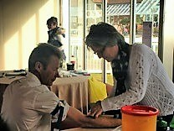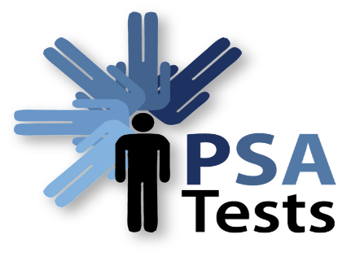

ALL MEN AGED 40 AND OVER

**PSA BLOOD TESTING EVENING**

**Detecting the early signs of prostate disease**

**DROP IN SESSION - THURSDAY 20th JUNE 2019**

AT: **THE NELSON CLUB**

CHARLES STREET,

WARWICK

CV34 5LE

**6.30PM TO 8.45PM**

www.psatests.org.uk

A DONATION TOWARDS THE COST OF EACH TEST WOULD BE GRATEFULLY RECEIVED

*RAISING PROSTATE HEALTH AWARENESS*



Like us on Facebook

www.facebook.com/PSATests



Follow us on Twitter

@PSA_Tests

